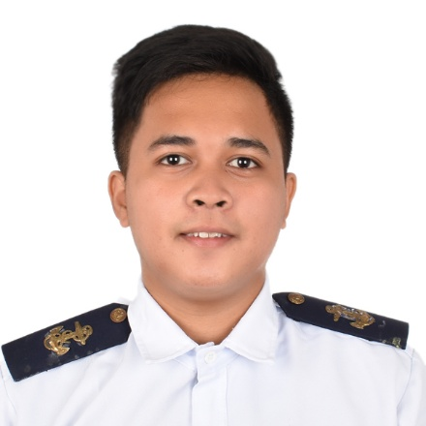
John Vincent T. Marasigan
Block 22 lot 23 White Gardenia St. Capitol Hills Subdivision Phase 1, Barangay Lapidario Trece
Martires City, Cavite
09165610807 | jayvmarasigan1228@gmail.com
Facebook Account - John Vincent Marasigan

Objective
To challenge myself and my knowledge in a new career.
To enhance my professional skills, capabilities and knowledge in an organization this recognizes the value of hard work and trusts me with responsibilities and challenges.

Education
Trece Martires City National High School
Fourth Year Senior 2009-2013
PNTC COLLEGES
BS Marine Transportation 2013-2016

Personal Details
Date of Birth: August 16, 1996
Place of Birth: Calapan City, Orriental Mindoro
Marital Status: Single
Nationality: Filipino

Experience
Asian Marine Transport Corp.
Deck Cadet 07/28/2018 –08/22/2019

Trainings Attended
- Basic Training
COMPASS Training Center Incorporated. July 2021
- Proficiency in Survival Craft and Rescue Boat
PNTC Colleges Maritime Training Center December 2015
Renaissance Training Center Inc. February 2022
- Ship Security Awareness Training and Seafarers with Designated Security Duties
PNTC Colleges Maritime Training Center February 2016
- Advanced Training in Firefighting
PNTC Colleges Maritime Training Center December 2015
- Medical Emergency - First Aid
PNTC Colleges Maritime Training Center December 2015
- Ratings Forming Part of Navigational Watch
Mariana Academy of Maritime Studies, Inc. December 2020
- International Safety Management for Ratings
Renaissance Training Center, Inc. March 2022
- Consolidated Marpol 73/78 ANNEXES I-VI
Seatech Maritime Training and Assessment Center Inc. March 2022
- Risk Assessment
Renaissance Training Center Inc. March 2022

Marasigan, John Vincent T.

